# VALORANT COACHING

**A Project Report**

***Submitted by***

## SHIV AVASHIA

## BHAVIK BOLYA

## ANANAY AGARWAL

## SAMAR BANSOD

***Under the Guidance of***

Prof. Vijayetha Thoday

***in partial fulfillment for the award of the degree of***

## B. Tech (Computer Engineering)

At



**MPSTME, Mumbai**

**Nov, 2020**

## DECLARATION

I, **Shiv Avashia, Roll No. 9,** B. Tech (Computer Engineering), V semester understand that plagiarism is defined as anyone or combination of the following:

1. Un-credited verbatim copying of individual sentences, paragraphs or illustration (such as graphs, diagrams, etc.) from any source, published or unpublished, including the internet.
2. Un-credited improper paraphrasing of pages paragraphs (changing a few words phrases, or rearranging the original sentence order)
3. Credited verbatim copying of a major portion of a paper (or thesis chapter) without clear delineation of who did wrote what. ( Source: IEEE, The institute, Dec. 2004)
4. I have made sure that all the ideas, expressions, graphs, diagrams, etc., that are not a result of my work, are properly credited. Long phrases or sentences that had to be used verbatim from published literature have been clearly identified using quotation marks.
5. I affirm that no portion of my work can be considered as plagiarism and I take full responsibility if such a complaint occurs. I understand fully well that the guide of the seminar/ project report may not be in a position to check for the possibility of such incidences of plagiarism in this body of work.

Names: Shiv Avashia, Bhavik Bolya, Ananay Agarwal ,Samar Bansod

Roll Nos. : B009, B017, B004, B012

Place: Mumbai

Date: 11/3/2020

## CERTIFICATE

This is to certify that the project entitled “**Valorant Coaching**” is the bonafide work carried out by **Shiv Avashia** of BTech, MPSTME (NMIMS), Mumbai, during the V semester of the academic year **2020-21**, in partial fulfillment of the requirements for the Course Programming Language.

___________________

Prof. Vijayetha Thoday

Internal Mentor

_______________________ ________________________

Examiner 1 Examiner 2

## Table of contents

**CHAPTER NO. TITLE PAGE NO.**

1. PROJECT INTRODUCTION
2. MODULES IMPLEMENTED
3. SCREENSHOTS
4. CONCLUSION & FUTURE SCOPE
5. SOCIETAL APPLICATION (If any)

**1.Introduction**

Student Coaching Portal gives a general, interactive experience of a website used by a programming based coaching class, "**Valorant Coaching**", which provides Python, R, and Java courses. The website has been created from scratch, and employs the usage of HTML, CSS, JavaScript, PHP, and MySQL, to provide multiple functionalities to the website. The functionalities of the website range from having a login for an admin or student, a dashboard for the student, a registration page for new admissions, and a homepage. Overall, the website/project is a virtually accurate representation of a website that would be implemented by a real-life coaching class.

**2.Modules Implemented**

**1. HTML**: is the standard markup language for documents designed to be displayed in a web browser. It can be assisted by technologies such as Cascading Style Sheets (CSS) and scripting languages such as JavaScript.

**2. CSS**: is a style sheet language used for describing the presentation of a document written in a markup language such as HTML.

**3. JavaScript**: It is used for form validation and DOM functionalities.

**4. PHP:** It is used as server scripting language which communicates with MySQL database.

**5. MySQL**: is used as database to store student details and admin details.

3.Screenshots

* Homepage:

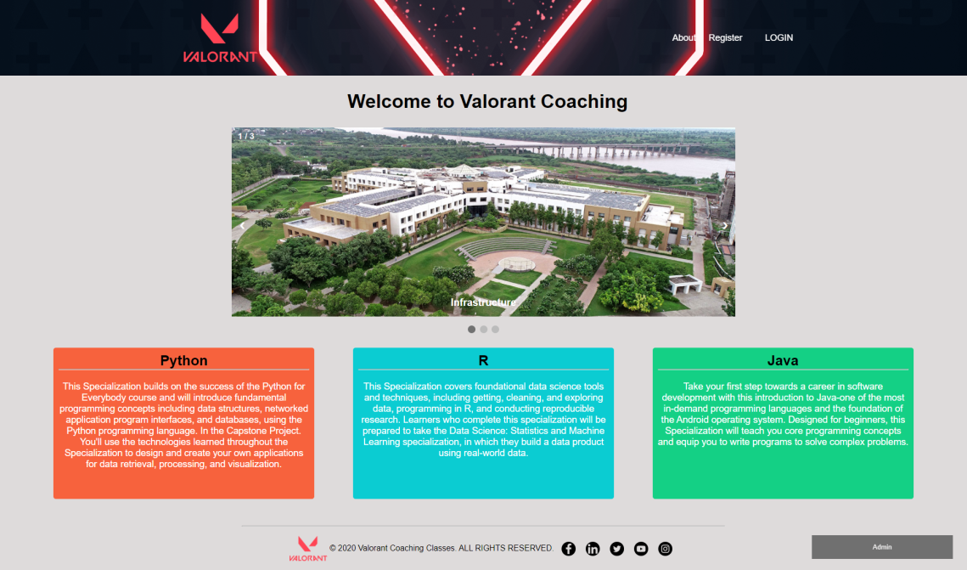

* About Us

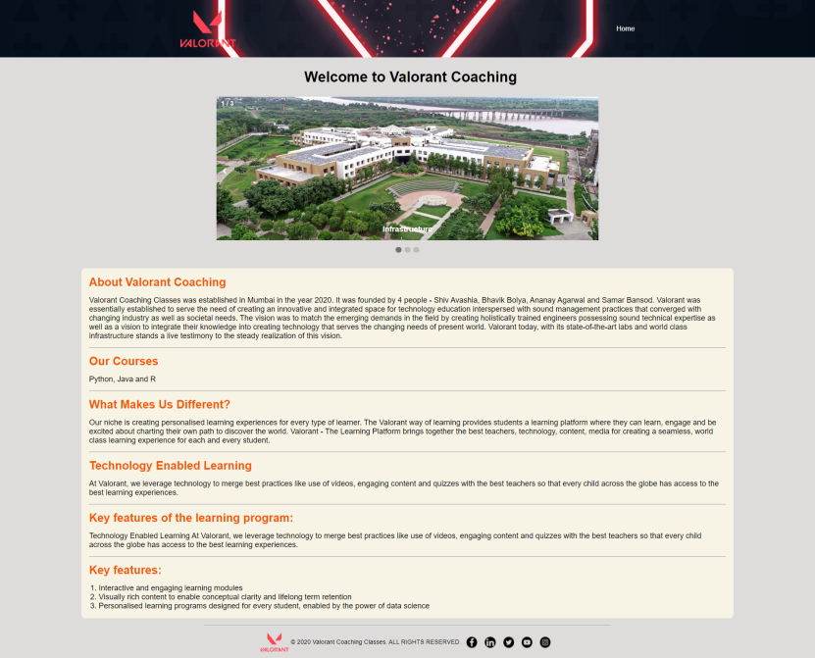

* Register

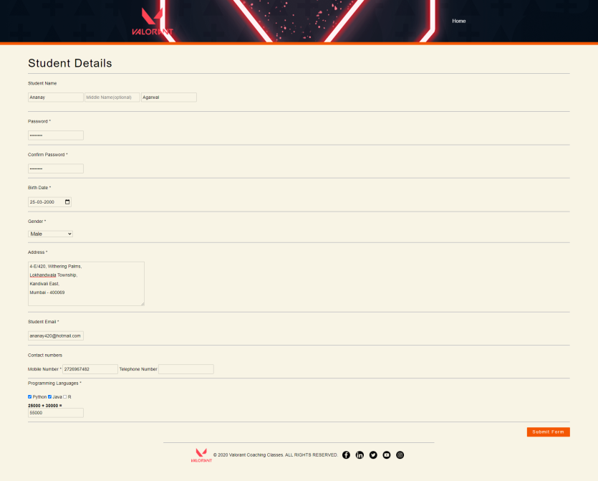

* Login

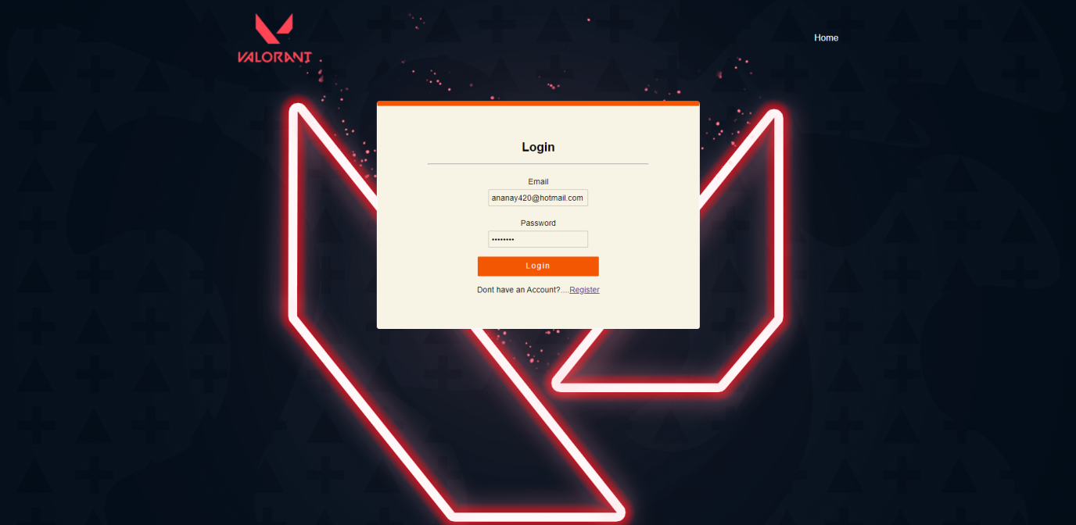

* Student Login

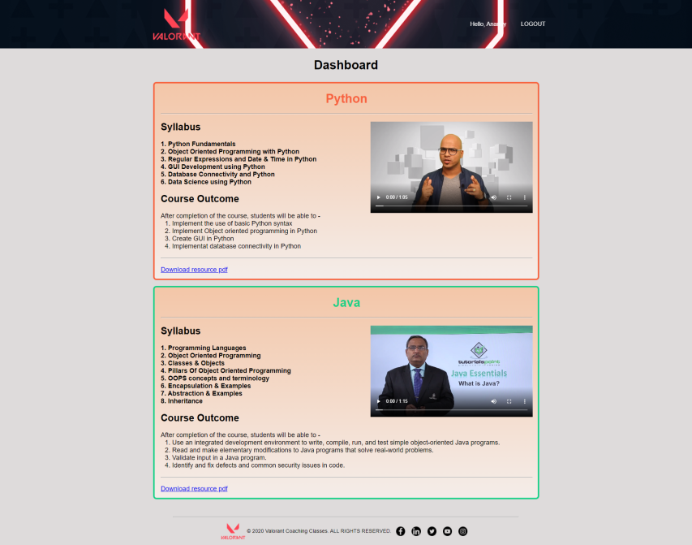

* Admin-Login

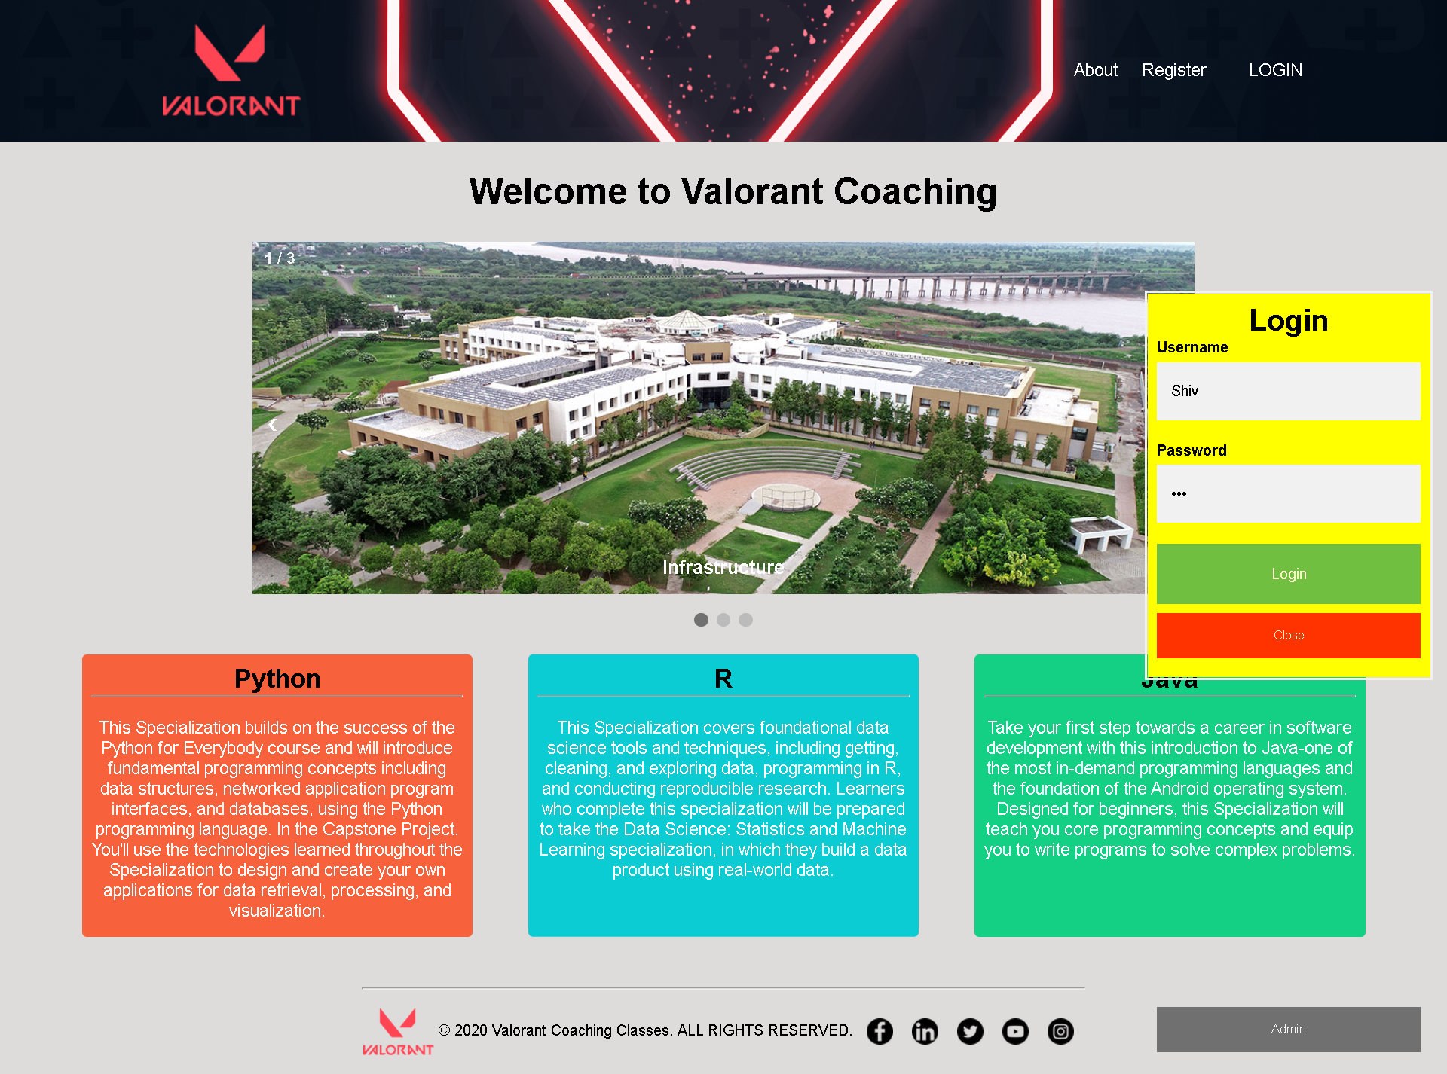

* Dashboard

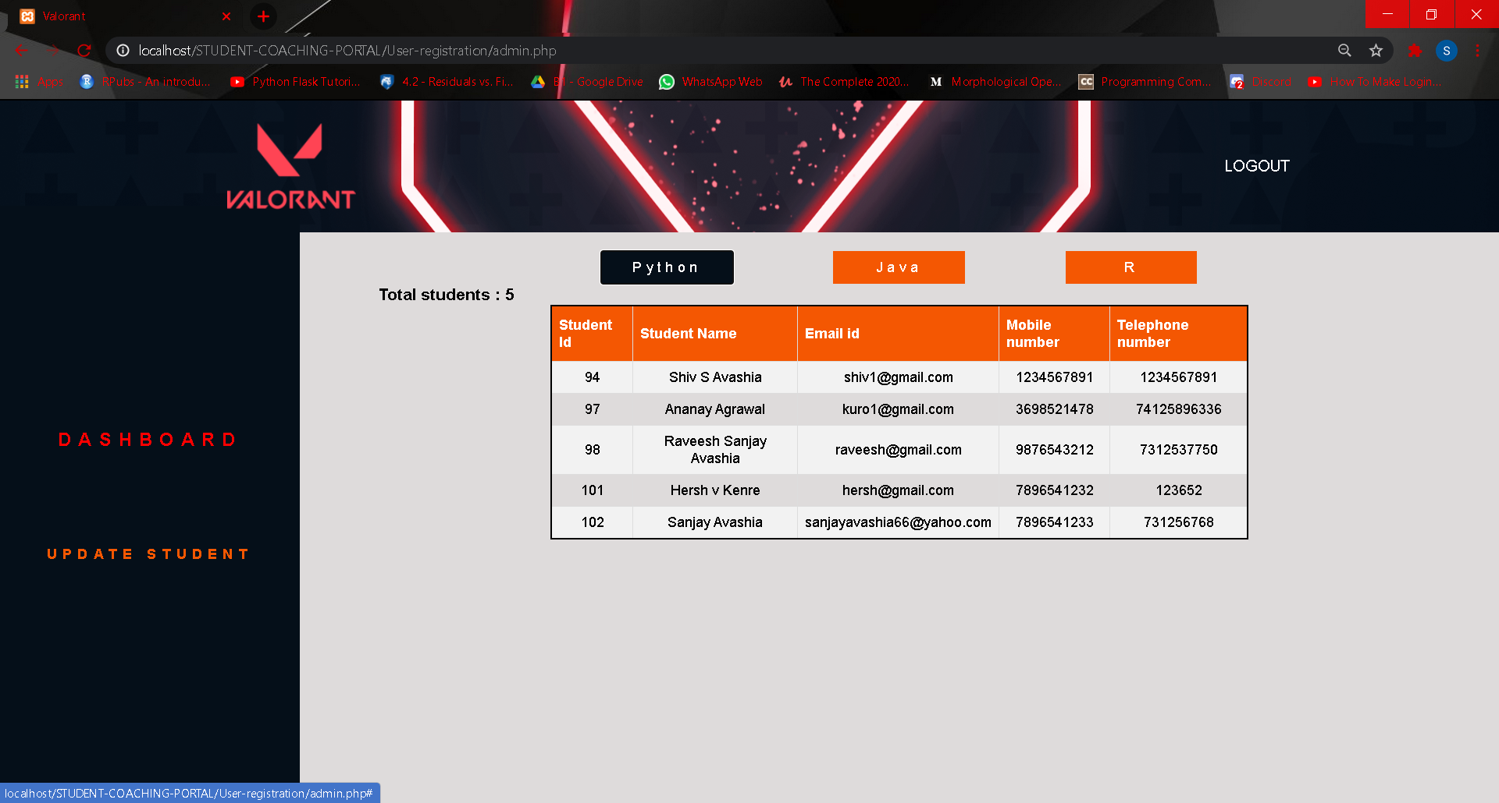

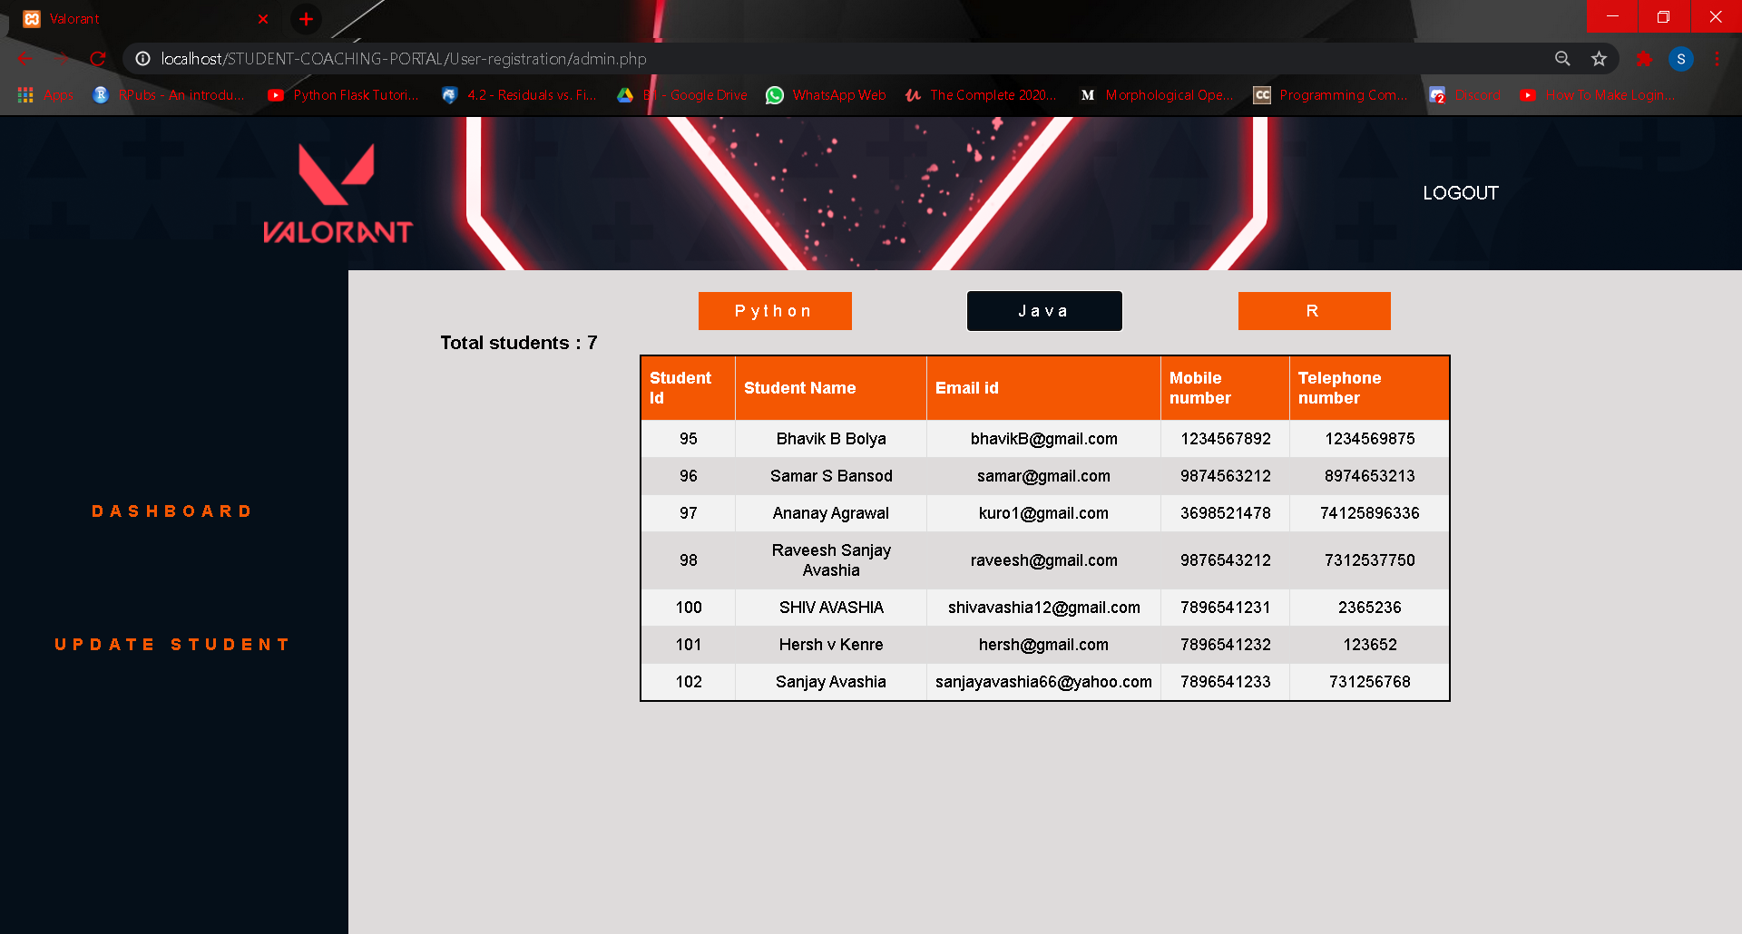

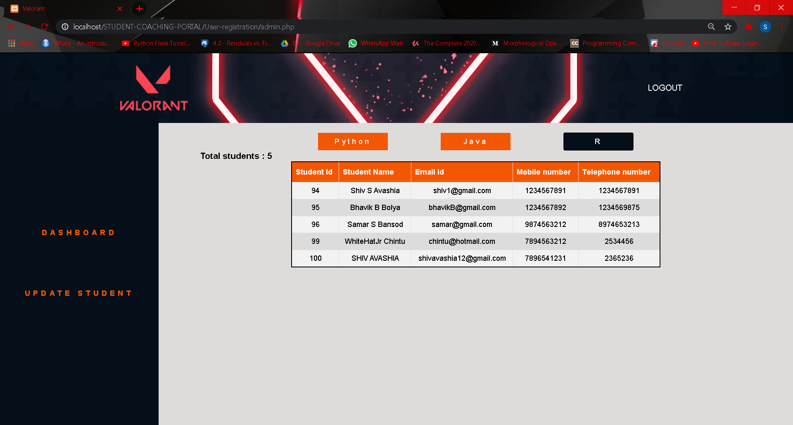

* Update -Delete Student

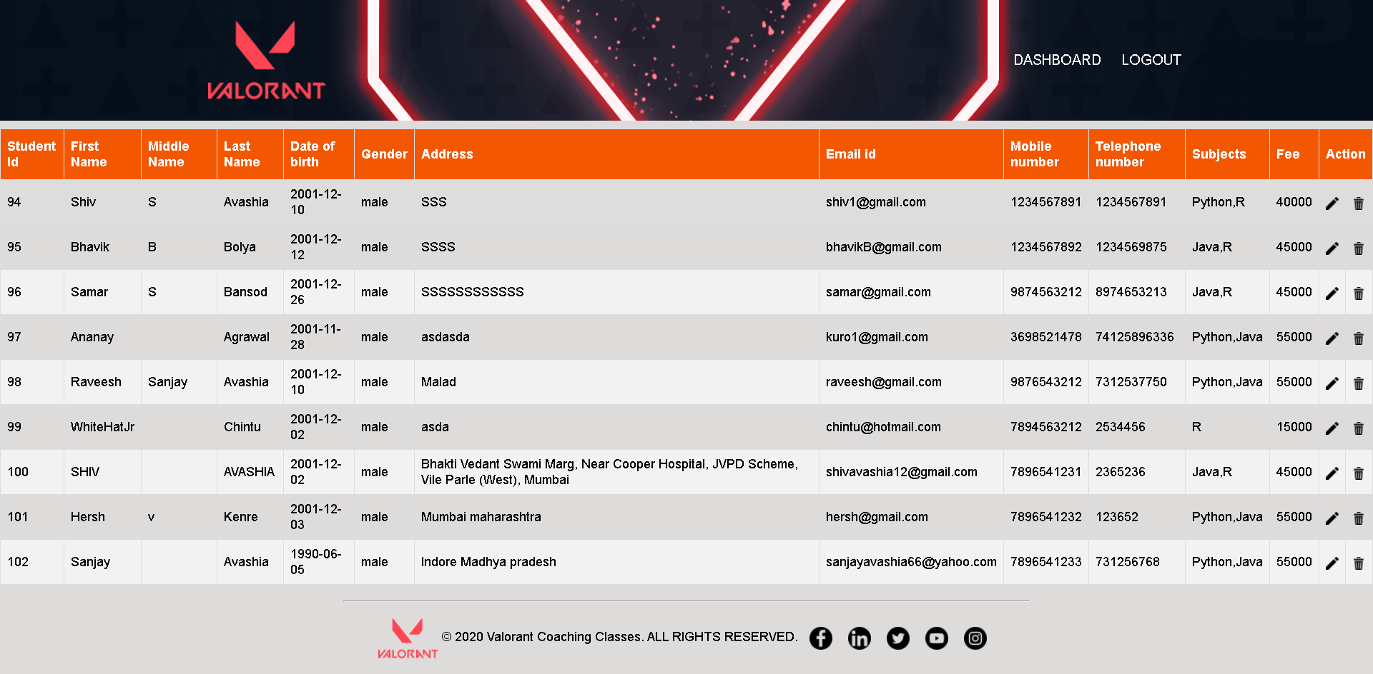

* Modify Details

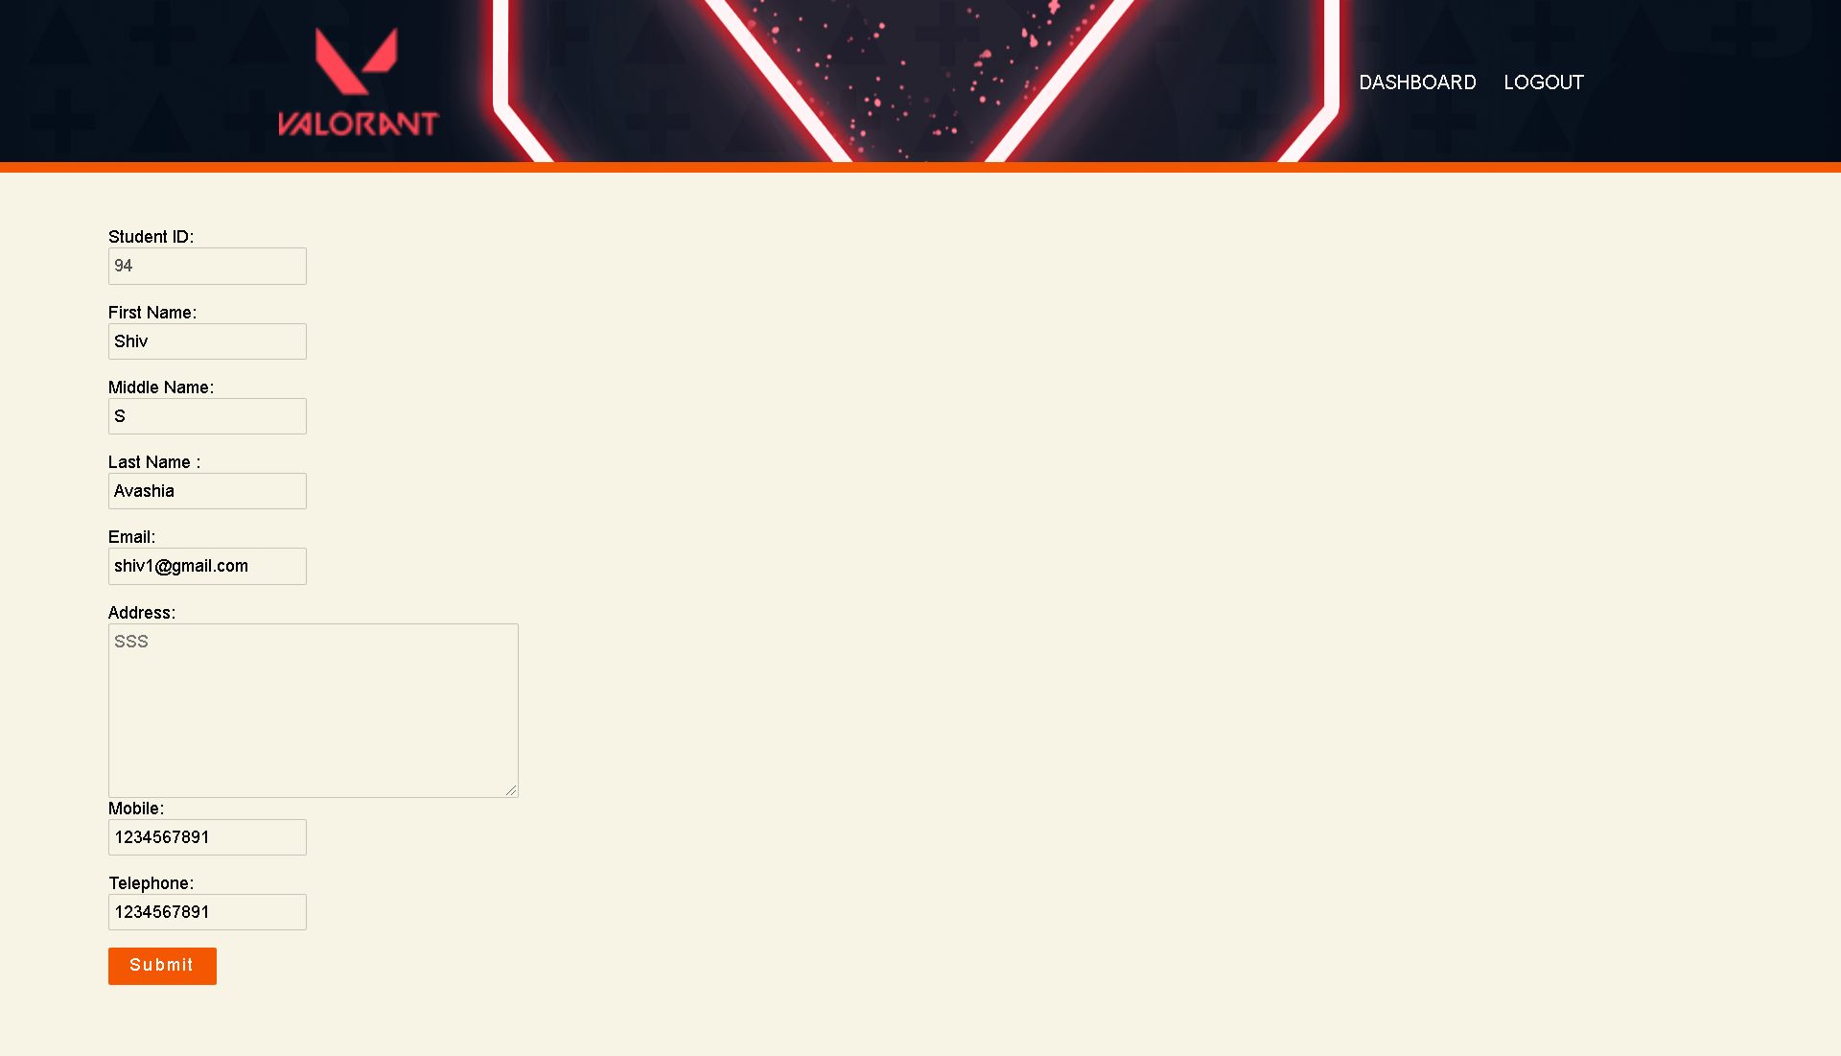

**4.Conclusion & Future Scope**

Conclusion The project employs HTML, CSS, PHP, JS, and MySQL. It provides a range of functionalities to the User, who are divided into two categories, Student and Admin. The functions include having a login for an admin or student, a dashboard for the student, a registration page for new admissions, and a homepage. The project is encompassing all aspects that could be required for a website of a coaching class. To conclude, this project provides an ideal example of a coaching website.

This project can be used as a template for a coaching class website. We can add further functionalities, such as a student can track their attendance, their exam marks, their due assignments, their internal grade marks, their course progress, and their study material required.

**5.Societal Application**

This project given the current situation would be ideal to use by coaching classes and educational institutes alike, since in-person learning is doubtful, this website would be of perfect assistance.